Microsoft Azure - Starter Kits for Partners

Pricing and Purchase Guidance

Last Update: March 2016





**MICROSOFT MAKES NO WARRANTIES, EXPRESS, IMPLIED OR STATUTORY, AS TO THE INFORMATION IN THIS DOCUMENT.**

The information contained in this document represents the current view of Microsoft Corporation on the issues discussed as of the date of publication. Because Microsoft must respond to changing market conditions, it should not be interpreted to be a commitment on the part of Microsoft, and Microsoft cannot guarantee the accuracy of any information presented after the date of publication.

Complying with all applicable copyright laws is the responsibility of the user. Without limiting the rights under copyright, no part of this document may be reproduced, stored in or introduced into a retrieval system, or transmitted in any form or by any means (electronic, mechanical, photocopying, recording, or otherwise), or for any purpose, without the express written permission of Microsoft Corporation.

Microsoft may have patents, patent applications, trademarks, copyrights, or other intellectual property rights covering subject matter in this document. Except as expressly provided in any written license agreement from Microsoft, the furnishing of this document does not give you any license to these patents, trademarks, copyrights, or other intellectual property.

The descriptions of other companies’ products in this document, if any, are provided only as a convenience to you. Any such references should not be considered an endorsement or support by Microsoft. Microsoft cannot guarantee their accuracy, and the products may change over time. Also, the descriptions are intended as brief highlights to aid understanding, rather than as thorough coverage. For authoritative descriptions of these products, please consult their respective manufacturers.

© 2015 Microsoft Corporation. All rights reserved. Any use or distribution of these materials without express authorization of Microsoft Corp. is strictly prohibited.

Microsoft and Windows are either registered trademarks of Microsoft Corporation in the United States and/or other countries.

The names of actual companies and products mentioned herein may be the trademarks of their respective owners.

Contents

Overview 5

Azure Purchase Options 6

Direct Pay-as-you-go on Azure.Microsoft.com 6

Direct 12 Months Pre-Paid 7

Azure in Open Licensing 7

Enterprise agreements 8

Annual Payments 9

Cloud Solution Provider (CSP) 9

Summary of Purchase Options and resources 11

Member Offers 12

1. MSDN Subscribers 12

2. MPN members 12

3. BizSpark members 12

Azure Pricing Factors 13

Main Metrics: 13

Additional factors: 13

License Mobility through Software Assurance on Azure 14

Tools for Estimating Costs 15

Microsoft Azure Pricing Calculator - **MOSP** 15

Microsoft Azure Pricing Calculator - **OPEN** 16

Microsoft Azure (IaaS) Cost Estimator Tool 16

Price FAQ 17

Services Cost Guidance 17

# Overview

The purpose of this document is to provide Microsoft Partners with a great understanding of the Microsoft Azure Purchase options and guidance on what are the key factors driving a Microsoft Azure deployment cost. It will also elucidate what are the current tools available to help estimate costs to migrate or develop new solutions on the Microsoft Azure Platform.

The concepts mentioned here are not limited to the context of an Azure Starter Kit, thus it provides guidance on pricing and licensing of the platform in general.

In this document, we will cover the following topics:

* Azure Purchase Options
* Azure Pricing Factors
* License Mobility through Software Assurance on Azure
* Tools for estimating Azure Solutions cost

# Azure Purchase Options

Azure is available for purchase in [140 countries around the world](https://azure.microsoft.com/en-us/pricing/faq/), and we support billing in 24 currencies. You can purchase Azure resources using one of multiple ways:

Essentially, customers have two modes to purchase Azure services: 1) Pay-As-You-Go Plan 2) Volume Discount. Each mode will provide the following benefits:

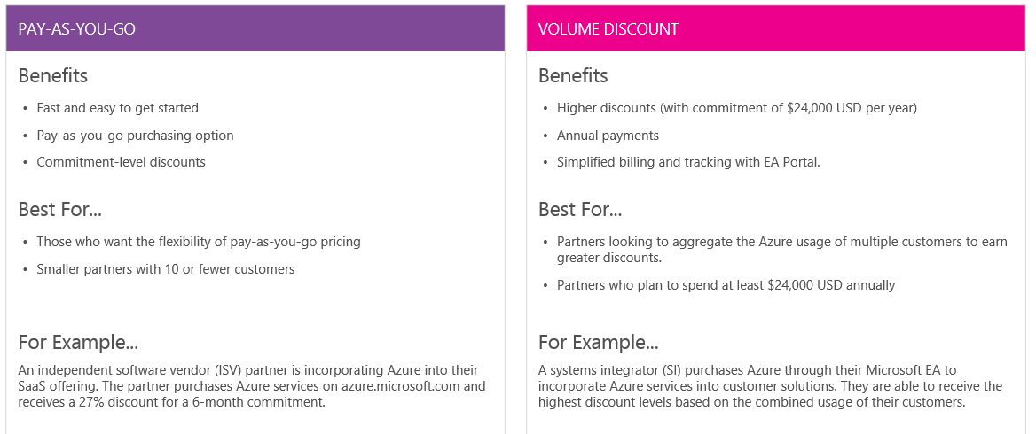

With **Azure in Open**, starting on August 1, 2014, Azure became available through another familiar licensing option that offers the benefits of Microsoft Volume Licensing and flexible monetary payments. Azure is also available direct, via **azure.microsoft.com**, or as part of a **Microsoft Enterprise Agreement (EA).**

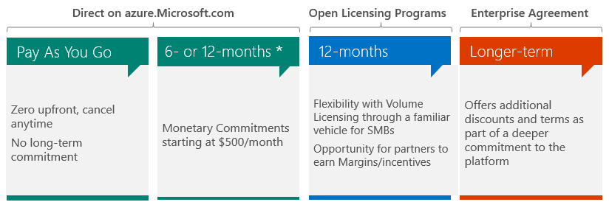

12-month term and receive a 5% discount on Azure services. The minimum purchase is $6,000

12 Months Pre-Paid *

In addition, Customers can buy from a Microsoft Reseller. They work with the same resellers that you may purchase Microsoft software from currently under the **Open Volume License Program** or **Cloud Solution Provider Program**.

## Direct Pay-as-you-go on Azure.Microsoft.com

Pay for what you use. Eliminate up-front costs, move from cap-ex to op-ex

No commitment. Pay for what you use each month

You can cancel any time

## Direct 12 Months Pre-Paid

Prepay for Azure services for a 12-month term and receive a 5% discount on Azure services. The minimum purchase is $6,000. You will be billed at the time of purchase. If you have an unused balance at the end of the 12-month term, your funds will be forfeited.

**Discount Details**

The offer discount rate is applied against the Pay-As-You-Go rates for the portion of your usage up to your prepaid purchase amount. Any usage exceeding the prepayment purchase amount will be billed at the standard Pay-As-You-Go rates.

**Exclusions**

Your prepaid funds may not be used to purchase (and discounts will not apply to) Azure support plans, third-party branded products, products sold through Azure Marketplace, or products otherwise sold separately from Azure (for example, Azure Active Directory Premium).

Azure storage capacity is excluded from the discounts.

The discount rate cannot be combined with the graduated discount provided as part of the Pay-As-You-Go rates for Azure Storage, Data Transfer, Content Delivery Network, Media Services, and any other Azure service for which the pricing is dependent on the volume of use of that service. For these services, the discount is applied against the base price tier.

**Payment Options**

You may pay by credit card, debit card, or invoice. Please note that we do not accept prepaid and virtual credit cards. If you choose to pay by invoice, your service activation may be delayed pending credit verification.

[More details](http://azure.microsoft.com/en-us/offers/ms-azr-0026p/)

## Azure in Open Licensing

Azure in Open Licensing is designed to simplify doing business on Azure, with a familiar licensing option that enables partners to easily add cloud services along with your other on-premises solutions.

With Azure in Open, Azure is available through another familiar licensing option that offers the benefits of Microsoft Volume Licensing and flexible monetary payments.

**What is Azure in Open?**

A monetary commitment, that expires in 12 months and that a customer can use against any consumption-based Azure service.

**How** **does a purchase work?**

Customers purchase Azure in Open from their reseller in the form of an Online Service Activation (OSA) Key that represents a specified monetary credit to a customer’s account

**Benefits:**

* Low barrier of entry. Grow your cloud business without any investments in complex billing systems and procured through your existing Distributor.
* A consistent, familiar licensing option. Do business using the same program for cloud services and on-premises solutions.
* Grow revenues. Generate recurring revenue streams while building long-term relationships with your customers.
* Increase margins. Offer fixed-fee engagements with optimized delivery and grow your higher-margin services.
* Capitalize on Infrastructure as a Service (IaaS) scenarios. With Windows Server 2003 end of support since July 2015, Azure in Open presents a huge opportunity to drive customers to the IaaS layer of service.

**Services:**

Azure in Open Licensing credits can be applied towards any Azure Service that is eligible for Monetary Commitments, when purchased online. Services that are not eligible for use with monetary commitments, such as Azure RMS and Azure Active Directory Premium, cannot be procured using Azure in Open.

[Read More](http://azure.microsoft.com/en-us/offers/ms-azr-0111p/)

[Partner Resource Material](https://readytogo.microsoft.com/global/_layouts/RTG/CampaignViewer.aspx?CampaignUrl=https://readytogo.microsoft.com/global/campaign/pages/(global)%20microsoft%20azure%20in%20open%20licensing.aspx)

## Enterprise agreements

Any Enterprise Agreement customer can add Azure to their **EA by making an upfront monetary commitment to Azure**. That commitment is consumed throughout the year by using any combination of the wide variety of cloud services Azure offers from its global datacenters. If a customer’s usage exceeds their commitment, they will be billed in-arrears for that usage, either quarterly or annually depending on whether that additional use is more than 50% beyond their original commitment.

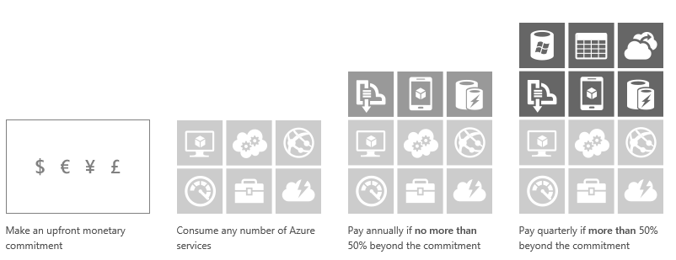

The Enterprise Agreement offers enterprise customers **four distinct benefits** as they invest in Azure.

|  |  |  |  |
| --- | --- | --- | --- |
| Best Prices | Purchase Simplicity | Annual Payments | Enterprise Portal |
| Get our best Azure prices based on their infrastructure spend—regardless of their upfront Azure commitment. These discounts are provided on top of per meter prices. | Microsoft has also extended those same great rates to unplanned growth customers have on Azure, so they can grow as their organizations’ need | Enterprise Agreement customers with direct relationships with Microsoft can pay Microsoft at the end of the year for unplanned growth, as long as use is within certain thresholds | Azure via the Enterprise Agreement also gives customers access to the Enterprise Portal, a great resource for customers managing multiple accounts or subscriptions |

[Learn more](http://azure.microsoft.com/en-us/pricing/enterprise-agreement/)

## Cloud Solution Provider (CSP)

The Microsoft Cloud Solution Provider program enables partners to directly manage their entire Microsoft cloud customer lifecycle. Partners in this program utilize dedicated in-product tools to directly provision, manage, and support their customer subscriptions. Partners can easily package their own tools, products and services, and combine them into one monthly or annual customer bill.

**What are the benefits of CSP?**

By participating in the CSP program, you can benefit from the following:

* You are the first point of contact for your customers’ needs
* You own and control the billing cycle
* You sell integrated offers and services – one sales motion to drive services, attach, and upsell
* You receive in-product tools to directly provision, manage, and support your customers

Are there partner investments required?

* New investments will vary based on your current practice. Areas to consider:
* Ability to transact billing on a monthly and/or annual basis
* 24/7 end customer billing and technical support in local language
* Local tax implications of selling a subscription product versus a service
* Adjustments to your sales incentive programs to reflect monthly revenue recognition
* Management of credit risk and collections
* Risk of transaction fraud

**How does this benefit customers?**

Customers can more easily purchase partner tools, products, and/or services with their subscription in one predictable monthly bill. Beyond the inherent benefits of the cloud, customers will have more frequent partner interactions which can serve to deepen the relationship. Studies show that 67% of customers expect to purchase a wide variety of cloud services from a single vendor and 84% of customers want an established relationship with a vendor to trust them as their Cloud Service Provider*.

*IDC Successful Cloud Partners 2013, IDC Buying Into the Cloud 2014, 2014 Forrester TRUE Brand compass

**How does this impact the way I sell today?**

The cloud and product value of Microsoft Office 365, Microsoft Intune, Enterprise Mobility Suite, Microsoft Dynamics CRM Online, and Microsoft Azure are exactly the same. This is simply one of the business models partners can consider when selling Microsoft cloud subscriptions. If you have the resources to provide complete customer lifecycle management and want to own the customer billing and support relationship, this model may be a great fit for your business.

**Is this a new channel model?**

The Cloud Solution Provider program has two models of enrollment available for partners. Partners should evaluate and choose a program that best meets their business requirements.

The 1-Tier model is a high capability model where partners work directly with Microsoft and they sell to their customers. If you select this model, you will take the responsibility of providing your end customers’ product and billing support.

If you don’t have support and billing capabilities today, and you currently work with distribution partners, the 2-Tier model is the right choice for you**. In this model, you will own the customer relationship and the CSP distribution partner will provide the end customer billing and product support.**

**Which customer segments can I sell?**

You can sell to any commercial customer. Enterprise Agreements may offer additional discounts, but this will vary based on your value added services offering. Although pricing pressure may be felt at deals with larger seats (e.g., 1,000), there is no seat cap.

[Learn More](https://partner.microsoft.com/en-us/solutions/cloud-reseller-faq)

## Summary of Purchase Options and resources

|  |  |  |
| --- | --- | --- |
| **Type** | **Description** | **Resource** |
| Pay-As-You-Go Subscriptions | Pay-As-You-Go subscriptions are our most popular and flexible payment plan. There are no minimum purchases or commitments and you can cancel anytime. You can pay for them by credit-card as well as by invoice | [Learn more](https://azure.microsoft.com/en-us/offers/ms-azr-0003p/) |
| Prepaid Subscriptions | Our 12-month prepaid subscription for Azure services lets you earn discounts on the amount you prepay. If your service consumption exceeds the prepaid amount, you can make an additional prepayment to continue getting the discount, or simply pay as you go for future usage. You can pay by credit card or by invoice. | [Learn more](https://azure.microsoft.com/en-us/offers/ms-azr-0026p/) |
| Microsoft Resellers | You can work with the same resellers that you already purchase Microsoft software from using the [Open Volume License Program](https://go.microsoft.com/fwlink/?linkid=525145&clcid=0x409). If you already have purchased Azure from a reseller and have an Open license key, you can activate your Azure subscription or add more credits to it | [Learn more](https://azure.microsoft.com/en-us/offers/ms-azr-0111p/). |
| Enterprise Agreements | Large organizations often sign up for a Microsoft Enterprise Agreement (EA). By making an upfront usage commitment to Azure they earn several additional benefits—including flexible billing options and our very best prices | [Learn more](https://azure.microsoft.com/en-us/pricing/enterprise-agreement/) |
| Microsoft Cloud Solution Provider | Partners in this program are able to directly provision customer subscriptions and provide one monthly bill for both Partner and Microsoft services. They also directly manage their customer subscriptions with in-product tools in the Partner Admin Center and own the technical support relationship. | [Learn More](https://partner.microsoft.com/en-US/Solutions/cloud-reseller-overview) |
| Microsoft Azure Compute Option | A limited-time offer to use Azure compute resources flexibly and cost-effectively—the more compute services you use, the more you save | [Learn more](https://azure.microsoft.com/en-us/pricing/microsoft-azure-compute-option/) |
| Microsoft Azure Hybrid Use Benefit | Run Windows Server Virtual Machines on Azure at base compute pricing. Windows Server customers with Software Assurance are eligible for this benefit. | [Learn more](https://azure.microsoft.com/en-us/pricing/hybrid-use-benefit/) |

## Member Offers

### MSDN Subscribers

Software, services, support, training - MSDN subscriptions give you a wide range of resources that help you succeed as a developer on Microsoft platforms. With a huge library of both current and previous editions of Microsoft software, plus access to Microsoft’s ALM solution, you have the tools and information you need to support the entire development process. The following benefits are available depending on which subscription you choose.

* Receive a monthly credit to use on any Azure service (**up to $150/month**).
* MSDN subscribers get discounted hourly rates and no additional charge for using MSDN software on Azure for dev and test.
* MSDN subscribers pay only $0.06 per hour for additional small VMs – a 33-97% savings

[Learn more](http://azure.microsoft.com/en-us/pricing/member-offers/msdn-benefits/)

### MPN members

Get resources that help you build or expand your cloud practice. Microsoft Partner through their MSDN benefits can get access to Azure.

In addition, MPN partners can use their MPN benefits to submit Azure technical incidents.

### BizSpark members

Azure provides great benefits for BizSpark members. BizSpark members automatically receive the Azure benefit through their Visual Studio Ultimate with MSDN subscriptions. These benefits include $150 monthly credits of Azure, lower rates and no additional charge for using MSDN software on Azure. In addition, BizSpark members retain production use rights under this Azure benefits offer.

[Learn more](http://azure.microsoft.com/en-us/offers/ms-azr-0064p/)

# Azure Pricing Factors

In traditional IT, one would buy a set of hardware (network infrastructure, servers and so on), set it up, go through the configuration process and connect to the Internet. It is a one-time investment, with an employee to turn the knobs and bolts.

With cloud computing, a cost model replaces that investment model. You pay for resources like those that server power and storage based on their effective use. With Microsoft Azure, you can expect the following measures to be the main measure of your monthly bill for Infrastructure as a service scenario:

## Main Metrics:

1. Number of hours you’ve reserved a virtual machine (VM)
2. Bandwidth, measured per GB out (download)
   * For backup services, you are not charged for data egress
3. Amount of GB storage used – VMs disks, blobs, files, database
4. Virtual Network Gateway Hours

## Additional factors:

* Software Licensing Cost

Azure Virtual Machines prices does not include licensing for application running within Virtual Machines, with exception to Windows, SQl Server, and BizTalk that can have their licensing cost included in the Virtual Machine price.

* Azure Support Plan Option

Azure offers flexible technical support options for customers of all sizes - from developers starting their journey in the cloud to enterprises deploying business critical applications. These support options provide you with the best available expertise to increase your productivity, reduce your business costs, and accelerate your application development. E.g.

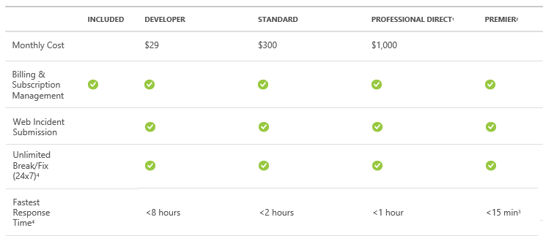

The business and architectural requirements of your application may have a direct impact on the cost of your Azure solution. Consider reviewing the following aspects of your application to include on cost estimation process:

* High-availability requirements – Resources redundancy may add up price
  + Azure guarantee 99.95% SLA for **Virtual Machines** that have two or more instances deployed in the same Availability Set. Therefore, you should consider adding an additional virtual machine instance to each part of you deployment requiring this SLA. However, such scenario may also have a direct impact on the average cost of your solution. [More Info](http://azure.microsoft.com/en-us/documentation/articles/virtual-machines-manage-availability/)
* Backup, Restore and Archiving – Data growth
* Auto scaling – E.g. dynamically scaling-up and scaling-down the compute instances number based on your application usage.
* For Dev and Test Scenarios, consider turning off Virtual Machines during non-development or testing time.
* For Production scenarios, you may save money by turning off Virtual Machines on non-business hours.
* Database size on SQL Azure

## License Mobility through Software Assurance on Azure

License Mobility through Software Assurance gives Microsoft Volume Licensing customers the flexibility to deploy eligible server applications with active Software Assurance on Azure. With this Software Assurance benefit, **there is no need to purchase new licenses and no associated mobility fees, so** you can easily deploy existing licenses on the Azure cloud platform

Eligibility Requirements

If you are a Microsoft Volume Licensing customer with eligible* application server licenses that are covered by active Software Assurance, you can elect to use License Mobility through Software Assurance.

Eligible Volume Licensing programs include the Enterprise Agreement, Microsoft Enterprise Subscription Agreement (EAS), and Microsoft Open Value Agreement, where Software Assurance is included, and other Volume Licensing programs where Software Assurance is an option, such as the Microsoft Open License Agreement or the Select Plus Agreement.

The following are key requirements for using License Mobility through Software Assurance with your eligible Volume Licensing products.

* License Mobility through Software Assurance only applies to eligible products as per the Product Use Rights (PUR) document. All products that are currently eligible for “License Mobility within Server Farms” and covered by Software Assurance are eligible for License Mobility through Software Assurance. In addition to those, certain other products can also be granted License Mobility through Software Assurance benefits, and will be identified in Appendix 1 of the PUR.
* Dynamics ERP products, while they are not available through Microsoft Volume Licensing and are not licensed online, have mobility rules that allow for similar use as License Mobility through Software Assurance when deploying in shared environments.
* Windows Server, the Windows® desktop operating system, and desktop application products are not included in License Mobility through Software Assurance.
  + Even though Windows Server is not covered under license mobility, Volume Licensing customers can still upload their own image containing Windows Server to Azure, if they are bringing it as part of Licensing Mobility for another product that is being brought over.
  + We will charge the Windows Server Virtual Machine rate applicable for their instance.
  + Starting on Feb 1, 2016, customers can get access to a cheaper per-minute-cost by utilizing the Azure [Hybrid Use Benefit.](https://azure.microsoft.com/en-us/pricing/hybrid-use-benefit/)
  + The Azure Hybrid Use Benefit lets those using Windows Server with Software Assurance bring their on-premises licenses to Azure. Rather than paying the full price for new Windows Server virtual machines in Azure, you only pay for the base compute rate*. For each Windows Server 2 processor license with Software Assurance, customers may run two virtual machines with up to 8 cores each, or one virtual machine with up to 16 cores, at the lower price
  + Customers are responsible for proper licensing of any application or middleware in the image
* Active Software Assurance coverage is required on eligible licenses. All licenses used to run and access your licensed software, such as server licenses, processors licenses, CALs, External Connector (EC) licenses, and server management licenses require active Software Assurance coverage. Your rights to run licensed software and manage instances on Azure expire with the expiration of the Software Assurance coverage on those licenses.
* You need to maintain eligible licenses on Azure for a minimum period of 90 days. After the 90-day period, you can move the licensed software back to your premise.

[More details](http://azure.microsoft.com/en-us/pricing/license-mobility/)

# Tools for Estimating Costs

## Microsoft Azure Pricing Calculator - **MOSP**

A complete pricing calculator (MOSP/retail price) accompanies this document to help measure the cost of your Azure solutions in general.

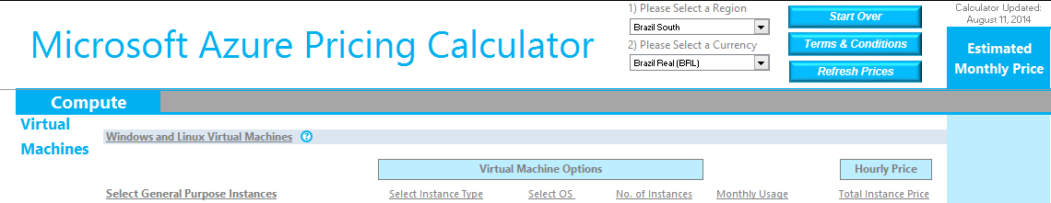

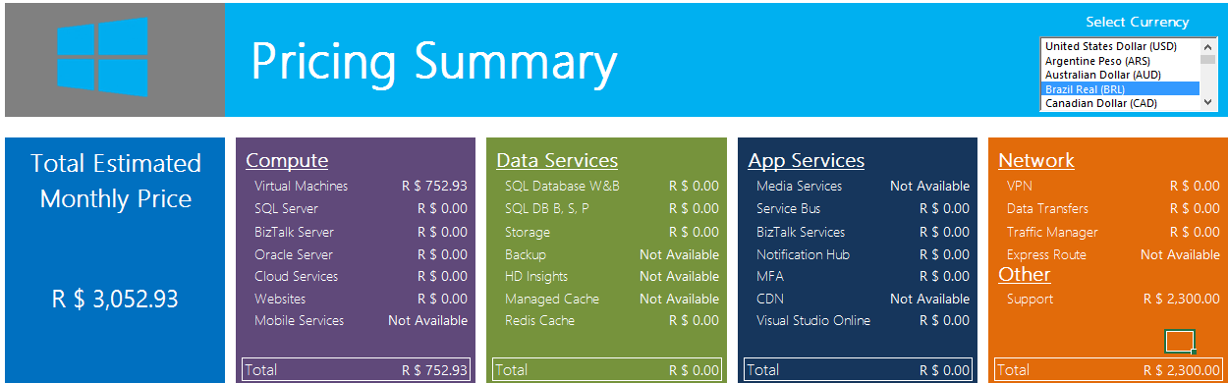

## Microsoft Azure Pricing Calculator - **OPEN**

A link for downloading the complete pricing calculator (OPEN) accompanies the Starter Kits to help measure the cost of your Azure solutions in general.



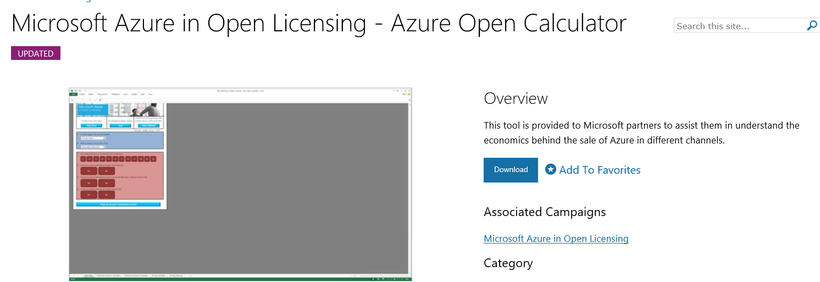

## Microsoft Azure (IaaS) Cost Estimator Tool

The Azure (IaaS) Cost Estimator has been designed to provide the IT manager of next generation organizations the ability to quickly assess running cost of the existing on-premises workload on the Microsoft Azure.   
  
**About the tool**

* The tool provides real world machine hardware usage
* It recommends appropriate Azure instance to match the scanned workload
* It also generates 30-day cost estimates of running such an Azure instance

**Features**

* The tool supports
  + Microsoft technologies (Hyper-V, SCVMM)
  + VMware technologies (vCenter, ESXi)
  + Physical environments (Windows, Linux)
* It is able to export to Excel/.csv that can be used for discussions with Systems Integration partner or a Microsoft representative
* No data is sent to Microsoft at any time. All report and profile information resides on the machine where the tool is installed

**Value Proposition:**

* Can be Installed and a profile scan completed within 15 minutes (can be deployed on a Windows client)
* Enables a comparison with on-premises running costs (e.g. hardware, power, cooling, building, security, and systems management among others)

[Download / More Details](http://www.microsoft.com/en-us/download/details.aspx?id=43376)

# Price FAQ

## Services Cost Guidance

* **Web Sites**

<http://azure.microsoft.com/en-us/pricing/details/websites/>

* **Virtual Machines**

<http://azure.microsoft.com/en-us/pricing/details/virtual-machines/>

* **Linux Virtual Machine**

<http://azure.microsoft.com/en-us/pricing/details/virtual-machines/#linux>

* **SQL Server Virtual Machine**

<http://azure.microsoft.com/en-us/pricing/details/virtual-machines/#sql-server>

* **SharePoint Virtual Machine**

<http://azure.microsoft.com/en-us/pricing/details/virtual-machines/#sharepoint>

* **Oracle Virtual Machine**

<http://azure.microsoft.com/en-us/pricing/details/virtual-machines/#oracle-software>

* **SQL Database**

<http://azure.microsoft.com/en-us/pricing/details/sql-database/>

* **Storage**

<http://azure.microsoft.com/en-us/pricing/details/storage-b/>

* **Virtual Network**

<http://azure.microsoft.com/en-us/pricing/details/virtual-network/>

* **Backup**

<http://azure.microsoft.com/en-us/pricing/details/backup/>

* **Bandwidth**

<http://azure.microsoft.com/en-us/pricing/details/data-transfers/>

* **Support**

<http://azure.microsoft.com/en-us/support/plans/>

* **Linux Support**

<http://azure.microsoft.com/en-us/pricing/details/virtual-machines/#linux>